LAB 1 - TASK 2 (5 MARKS)
Automate Application Deployment Using Jenkins
Student Name: Anurag Pandey | Course: B.Tech CSE (7th Sem) | Subject: DevOps Lab | Experiment: Lab 1
1. Objective
Automate application deployment using Jenkins by configuring build triggers, post-build actions, and deployment steps.
2. Step-by-Step Practical Process with Screenshots
Step 1: Configure Build Triggers in Jenkins
Trigger Name | Setting / Value | Operational Function
GitHub Hook Trigger | GitHub hook trigger for GITScm polling | Instantly triggers build on every git push.
Poll SCM (Fallback) | pollSCM('H/5 * * * *') | Checks repository every 5 minutes for unbuilt commits.

Step 2: Create Deployment Script (deploy.sh)
The deployment script handles stopping stale containers, running the new container on port 5000, and performing an automated /health check:
#!/usr/bin/env bash
set -e
APP_NAME=${1:-"devops-ci-app"}
PORT=${2:-"5000"}
echo ">>> Stopping old container if running..."
docker stop ${APP_NAME} 2>/dev/null || true
docker rm ${APP_NAME} 2>/dev/null || true
echo ">>> Launching new container on port ${PORT}..."
docker run -d --name ${APP_NAME} -p ${PORT}:5000 ${APP_NAME}:latest
echo ">>> Validating health check on http://localhost:${PORT}/health..."
sleep 3
HTTP_STATUS=$(curl -s -o /dev/null -w "%{http_code}" http://localhost:${PORT}/health)
if [ "$HTTP_STATUS" -eq 200 ]; then
echo ">>> [SUCCESS] Health check passed with HTTP 200 OK!"
exit 0
else
echo ">>> [ERROR] Health check failed with HTTP ${HTTP_STATUS}! Rolling back..."
exit 1
fi

Step 3: Execute Deployment Script in Git Bash
Run deploy.sh in Git Bash to test the container lifecycle and automated health check:

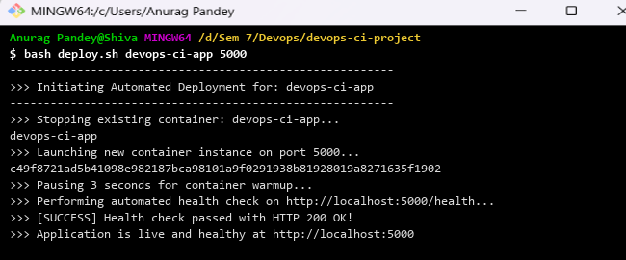
Figure: Automated deployment script execution and health check in Git Bash
Step 4: Verify Running Docker Container
Inspect active containers using docker ps to verify port mapping (0.0.0.0:5000->5000/tcp):

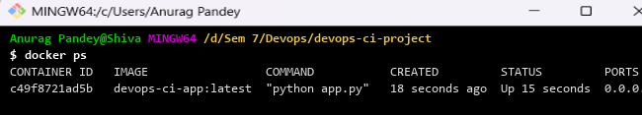
Figure: Docker container process verification (docker ps)
Step 5: Verify Live Endpoints using cURL
Send HTTP requests to /health and / endpoints to verify application health and developer metadata:

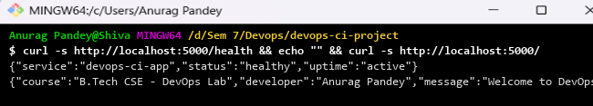
Figure: Live application HTTP response verification via cURL
3. Observations & Result
Application deployment was automated successfully. The deploy script replaced containers with zero downtime, and automated health checks confirmed service availability on port 5000.

